Spring Boot H2 Database

What is the in-memory database
In-memory database relies on system memory as oppose to disk space for storage of data. Because memory access is faster than disk access. We use the in-memory database when we do not need to persist the data. The in-memory database is an embedded database. The in-memory databases are volatile, by default, and all stored data loss when we restart the application.
The widely used in-memory databases are H2, HSQLDB (HyperSQL Database), and Apache Derby. It creates the configuration automatically.

Persistence vs. In-memory Database
The persistent database persists the data in physical memory. The data will be available even if the database server is bounced. Some popular persistence databases are Oracle, MySQL, Postgres, etc.
In the case of the in-memory database, data store in the system memory. It lost the data when the program is closed. It is helpful for POCs (Proof of Concepts), not for a production application. The widely used in-memory database is H2.

What is the H2 Database
H2 is an embedded, open-source, and in-memory database. It is a relational database management system written in Java. It is a client/server application. It is generally used in unit testing. It stores data in memory, not persist the data on disk.
Advantages
- Zero configuration
- It is easy to use.
- It is lightweight and fast.
- It provides simple Configuration to switch between a real database and in-memory database.
- It supports standard SQL and JDBC API.
- It provides a web console to maintain in the database.

Configure H2 Database
If we want to use H2 database in an application we need to add the following dependency in pom.xml file:
- <dependency>
- <groupId>com.h2database</groupId>
- <artifactId>h2</artifactId>
- <scope>runtime</scope>
- </dependency>
After adding the dependency, we need to configure data source URL, driver class name, username, and password of H2 database. Spring Boot provide an easy way to configure these properties in application.properties file.
- spring.datasource.url=jdbc:h2:mem:testdb
- spring.datasource.driverClassName=org.h2.Driver
- spring.datasource.username=sa
- spring.datasource.password=
- spring.jpa.database-platform=org.hibernate.dialect.H2Dialect
In the spring.datasource.url property, mem is the name of an in-memory database and testdb is the name of schema that H2 provides, by default. We can also define our own schema and database. The default username is sa and the blank password denotes an empty password. If we want to change the username and password, we can override these values.

Persist the data in H2 Database
If we want to persist the data in the H2 database, we should store data in a file. To achieve the same, we need to change the datasource URL property.
- #persist the data
- spring.datasource.url=jdbc:h2:file:/data/sampledata
- spring.datasource.url=jdbc:h2:C:/data/sampledata

H2 Console
By default, the console view of the H2 database is disabled. Before accessing the H2 database, we must enable it by using the following property.
- #enabling the H2 console
- spring.h2.console.enabled=true

Once we have enabled the H2 console, now we can access the H2 console in the browser by invoking the URL http://localhost:8080/h2-console. The following figure shows the console view of the H2 database.
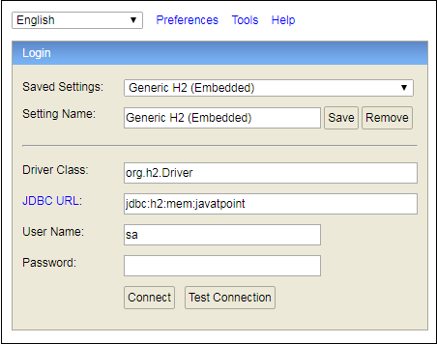

For Example
Spring Boot H2 Database - javatpoint

